IT ASSET REGISTER INSTALLATION MANUAL & User Guide

**DATE CREATED: OCTOBER 8th 2020**

**By JATT TEAM: TSICHU SHRESTHA - 30350321**

**HUA QUOC TIEN - 30362014**

**ARVINDER KAUR- 30338458**

**JYOTI KHADKA- 30345643**

Contents

**Introduction** 2

**Pre- requisites** 2

**Installation Procedures** 3

**Post installation - Configuration requirements** 6

**User guide** 10

**Uninstall or Roll-back** 16

**Introduction**

**Purpose-** the purposeof this document or the installation manual is to provide the support or guidance on how they can install the program on their system. All the requirements and installation procedure are given in detail in this document. The objective of this document is to set up a global rule for the contractors of IT Asset Register to build up their installation manual before the delivery of an installation (full installation, patch, bug fix, …)

**Installation manual-** In order to facilitate the integrators’ tasks, it is vital to provide the delivery with accurate, exhaustive, complete and clear installation instructions. So for the installation manual, the main components that should be completely and correctly described are as following:

Pre- requisites

Install procedure

User Guide

Rollback or Un-install procedure

**Pre- requisites**

In this section a list of install prerequisites are mentioned that must be fulfilled before the installation can begin. Therefore for the current application which is the IT Asset Register the prerequisites are as follow:

-Operating System- Windows OP

-Software Components used by the application: Application Software- sql express 2016 local database installed

-System Requirements (Software and/or Hardware) - needs at least 1GB disk space

**Pre- installation Tasks-** all the tasks that should be completed before the installation of the software delivery started need to be specified here. But, for the IT Asset Register Application there are just few tasks which need to be performed and must be made sure. First of all the internet connection should be there. The computer or desktop where the application is going to be installed, must be working well. There should be a 1GB desk space available, and etcetera.

**Installation Procedures**

Once all the prerequisite checks and controls are positively finished, the install process can start. This section is clear and explicit to describe the steps, in chronological order, the integrator or the user of application must follow to complete the task.

**Step 1:** IT-Asset-Register-Final.rar file must be downloaded from this [link](https://drive.google.com/file/d/1XvH7JxL4w-LV2pEL7UTOARtGfZnQOUVq/view?usp=sharing)

**Step 2:** Extract the files where you will initially see two files ITRegister-Setup and SqlLocalDB-Setup.

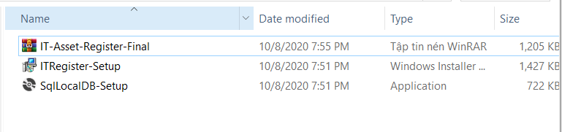

**Step 3:** Open Control Panel to see if Microsoft SQL Server 2016 LocalDB is installed (if yes then go to **step 6**)

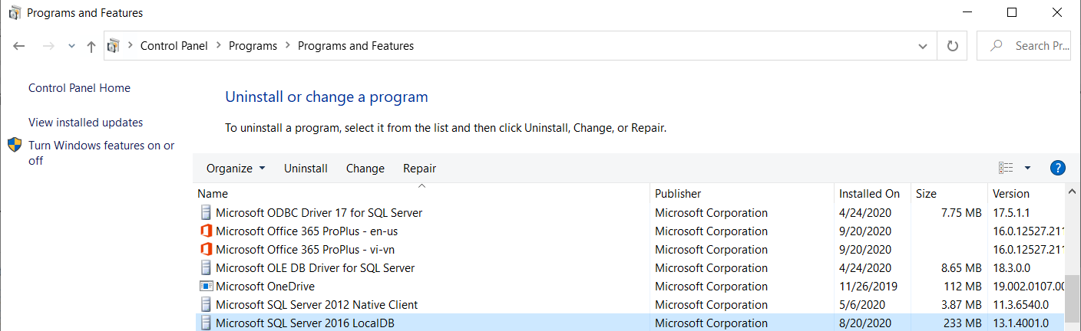

**Step 4:** Click on SqlLocalDB-Setup to install Sql LocalDB 2016 (click Accept to install)

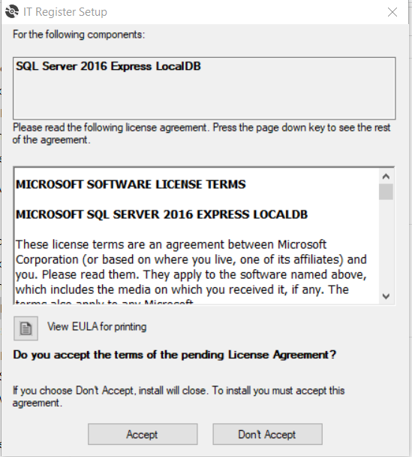

**Step 5:** Click on ITRegister-Setup to install the application

**Step 6:** Click Next

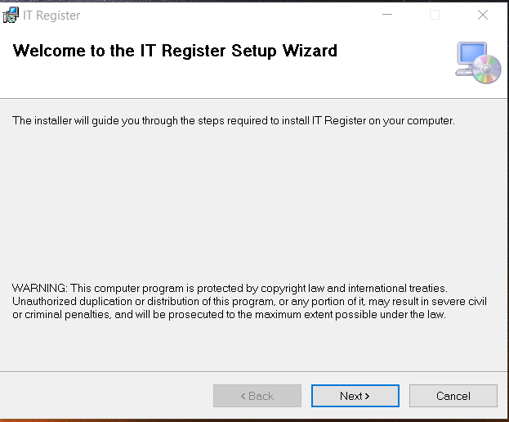

**Step 7:** Click Browse to choose location to install the application and click next to continuew (remember the install location as it is need in step )

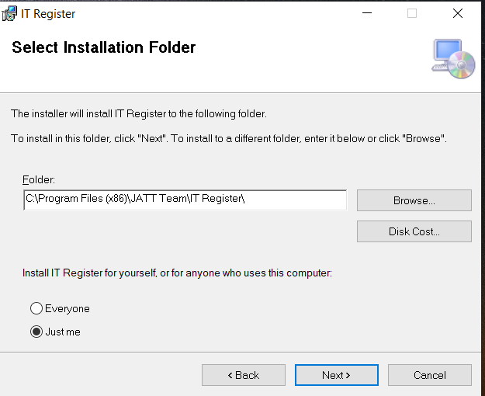

**Step 8:** click on Next button to confirm installation.

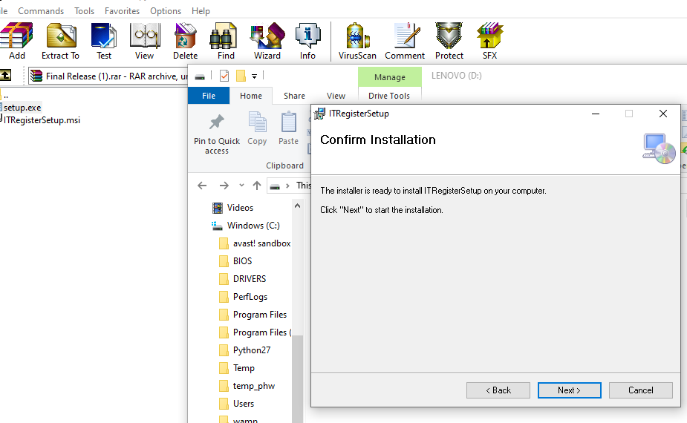

**Step 9:** Press on close to complete installation.

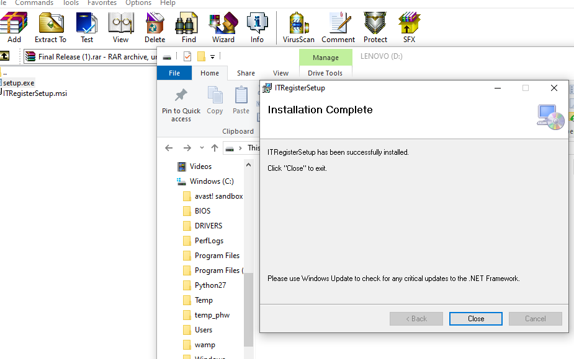

**Post installation - Configuration requirements**

There are some tasks that needs to be done after installing the program. Below is the list that details the post installation task.

* Go to the location where you installed the program where you will see all the files- ITAsset- Application file, ITAsset.exe- XML Configuration file, Asset-database.mdf- MDF File, Asset-database_log.ldf- LDF File.
* right click on Asset-database.mdf and then click on properties.
* Choose the Security tab and then click edit.. Button.

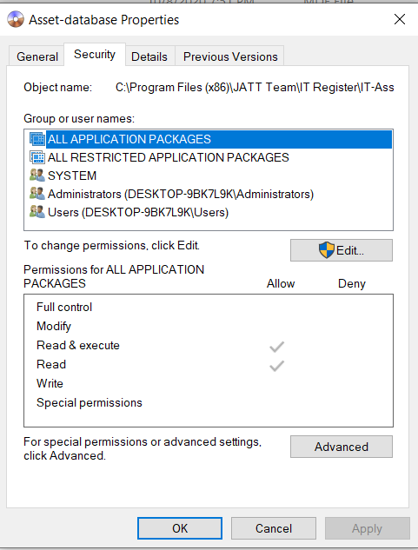

* Click on Allow Full Control for all the group and users name you can see in that property.

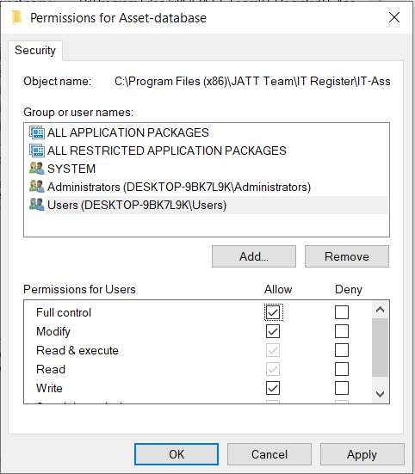

* After that click on Apply and press OK. Again click OK.
* Now go to ITAssetDatabase_log.ldf, right click on the file and then click on properties and do the same thing like above

Also, as the program records the time and date for the updated asset information and for when an asset is sent to archive so, it is very important that the date and time should be selected to correct format.

Here are some steps below to format the date and time. (depend on what regional format and language you use on your Laptop/PC, you need to put them in the same language, this installation perform on a Laptop/PC which use English(united states) regional format and language setting

* Go to start menu in your Laptop/PC.
* Search date and time setting and open it.
* Click on region from the menu and choose “English(united states) “ for the regional format option.

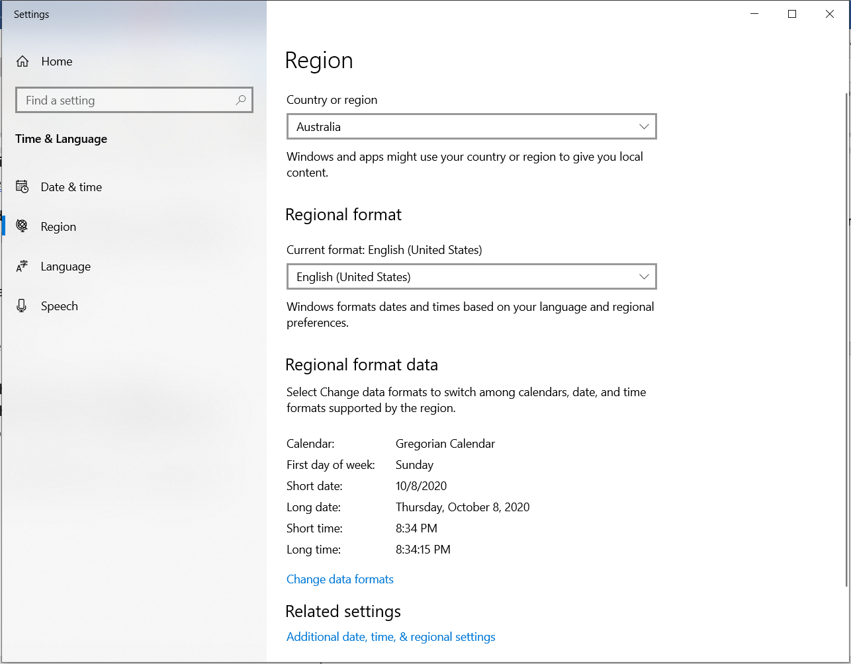

* Click on Language from the menu and choose “English (united states)” for the window display language option.

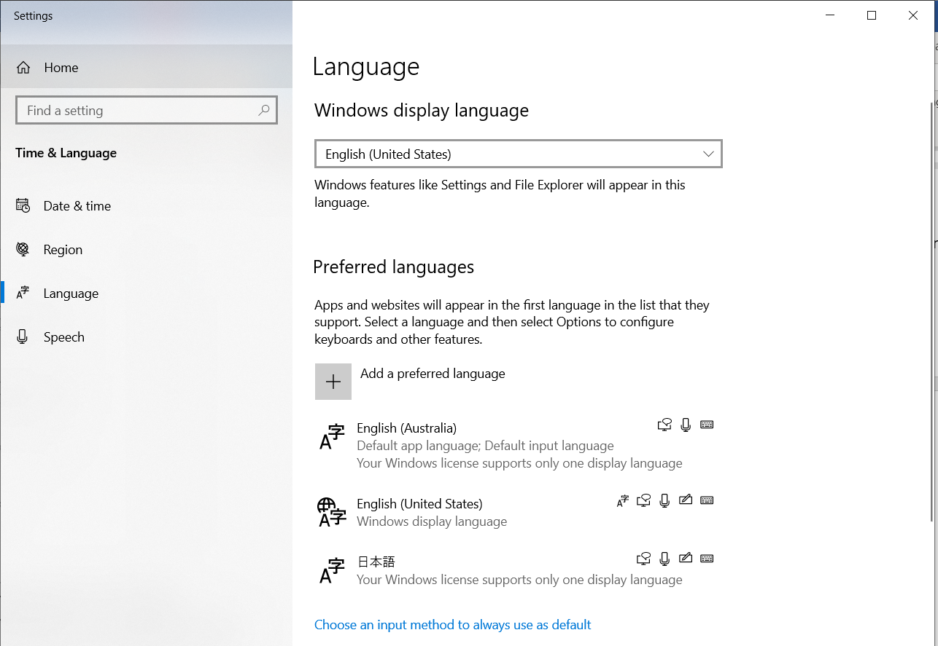

* Once the above task is completed, your date and time will be in correct format for the use of application.

**User guide**

* Now click on ITAsset- the Application file with a view to use the program.

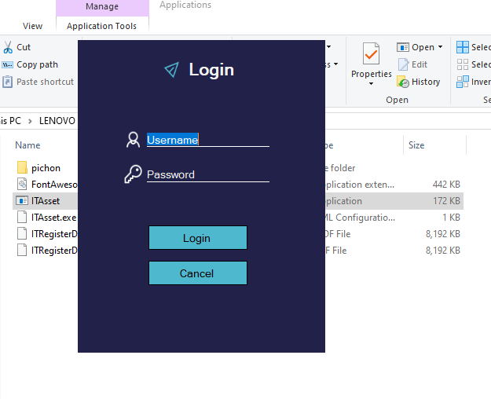

* You will come across a Login form and enter the username and password

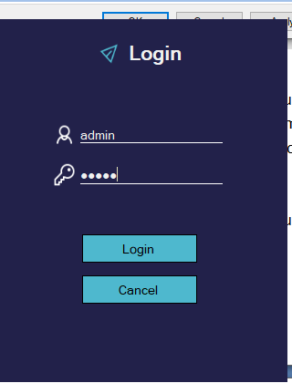

* After logged in, you will be guided to Home Menu of the Application

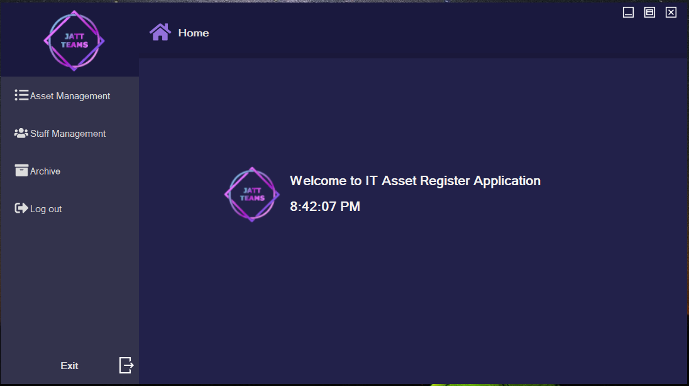- You can use the application depending on the type of authorized user you are having.

- In Asset Viewing menu you will have Item register, Update, Send to Archive option, you can also search for the item you want base on the category

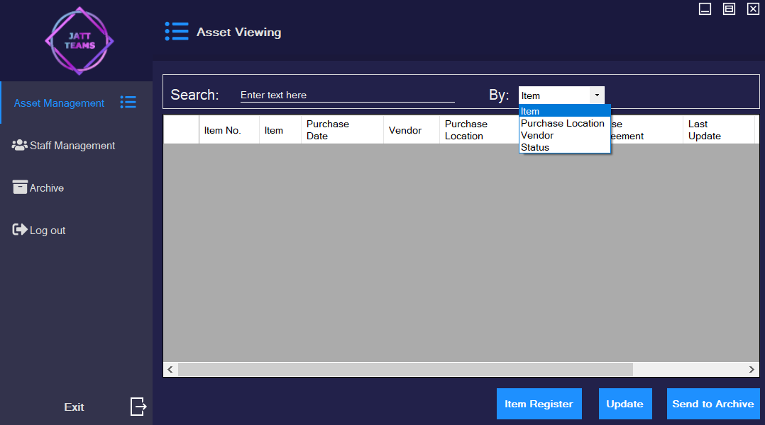

* Click on the Item Register button to register a new IT Asset (you can choose vendor from the list or add new one using Add button, you choose the status from the list which are Allocated, Burrowed, Purchased and Returned, if you chose Burrowed then you need to enter Lease Agreement)

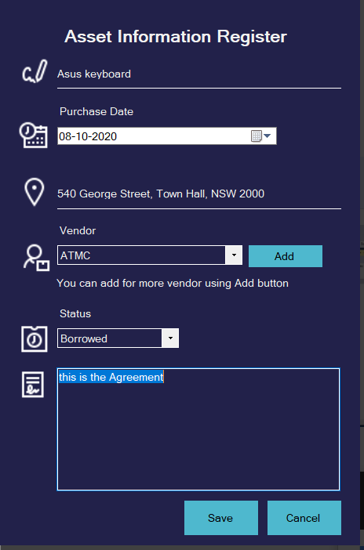

* Click Save and continue to add more asset or click Cancel to go back to the viewing menu, you can then choose the item you want to Update or Send to archive (click Send to Archive will send the selected item to the archive which can be opened from the Home Menu)

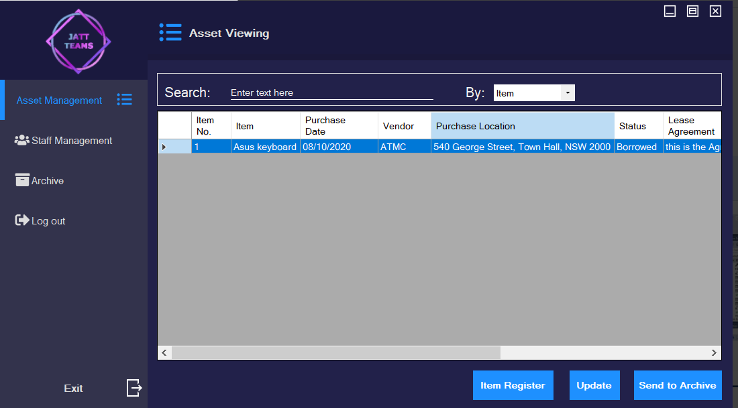

* In Asset Update, choose status other than Burrowed will automatically erase the Lease Agreement from the Asset

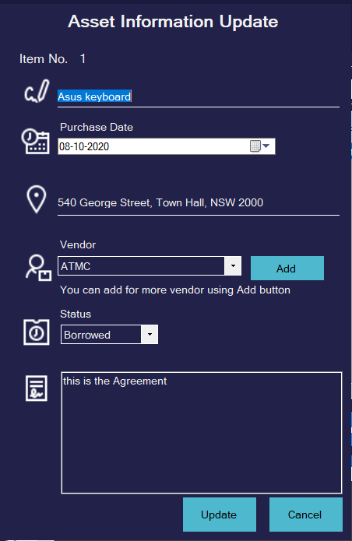

* Choose Item in Archive and click on Unarchive button to send selected item back to the asset viewing form

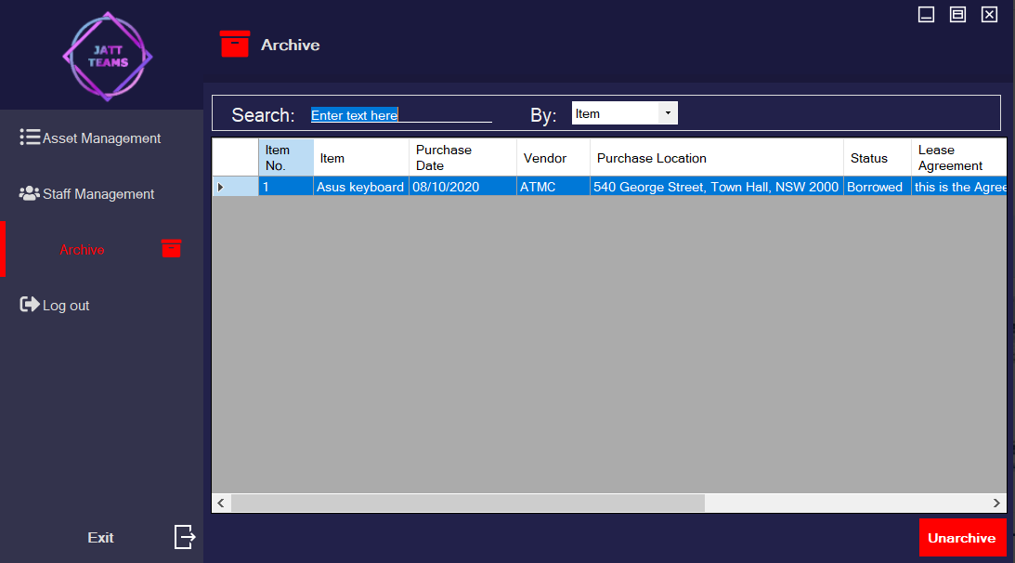

* In Staff Viewing menu you will have Add Staff, Update, Delete option, you can also search for the staff you want base on the category

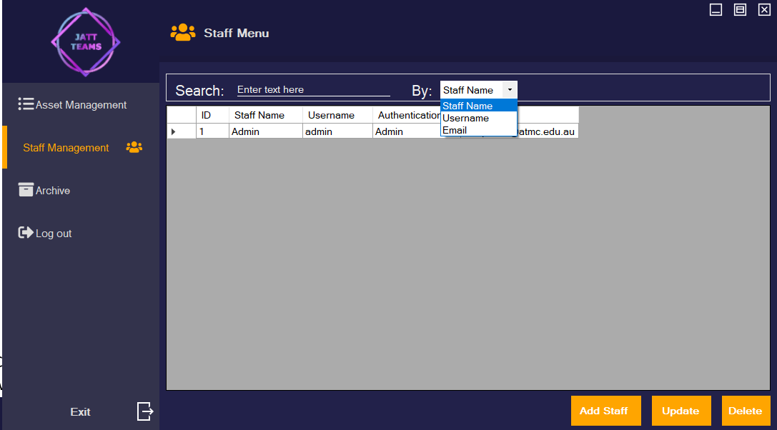

* Click on Add Staff to register a new staff, in the registering menu, you can choose Authentication type for the user (Super User don’t have access to Staff Management)

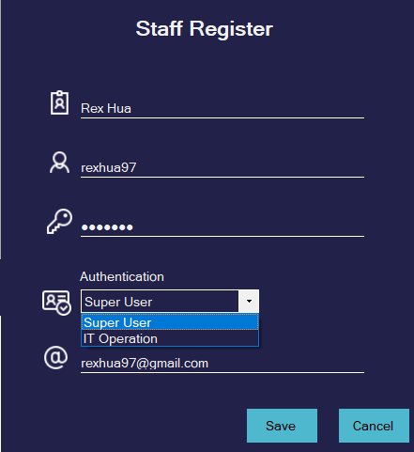

* Click Save and continue to add more staff or click Cancel to go back to the viewing menu, you can then choose the staff you want to Update or Delete

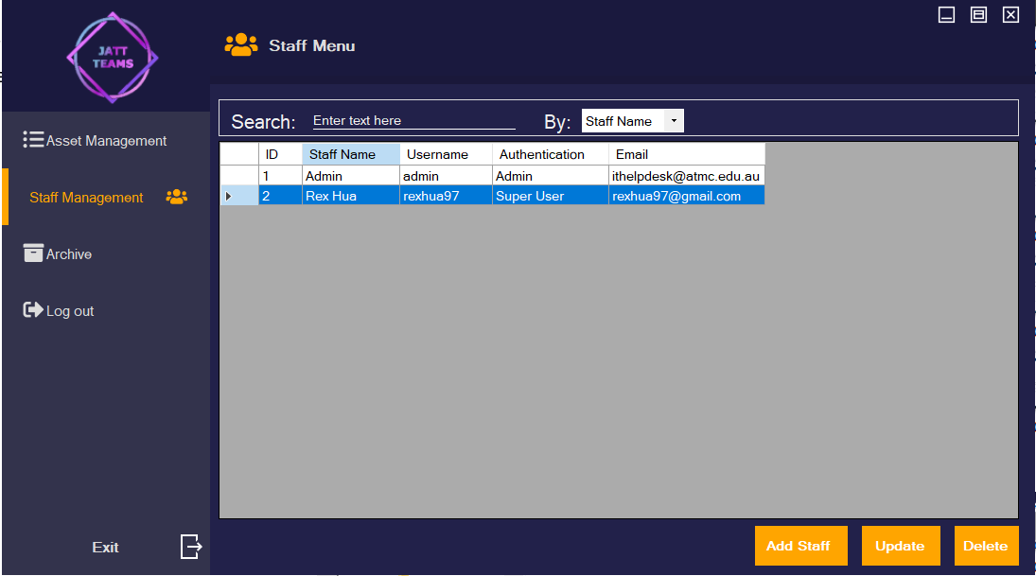

* After finished, you can click Exit to close the application or click Log out to log in with another Account

**Uninstall or Roll-back**

-To uninstall the application go to Control Panel on your computer.

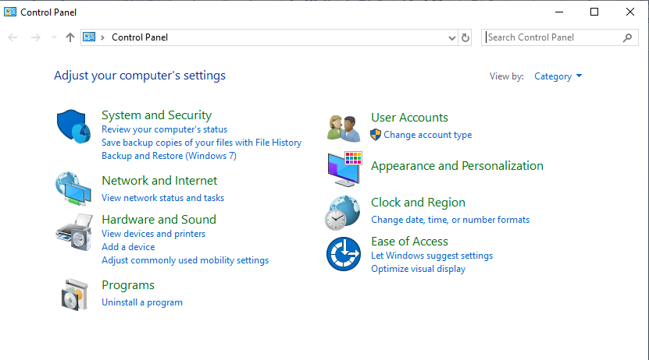

-On Control Panel window go to Programs-uninstall a program.

-Then choose the particular application you want to change or un-install.

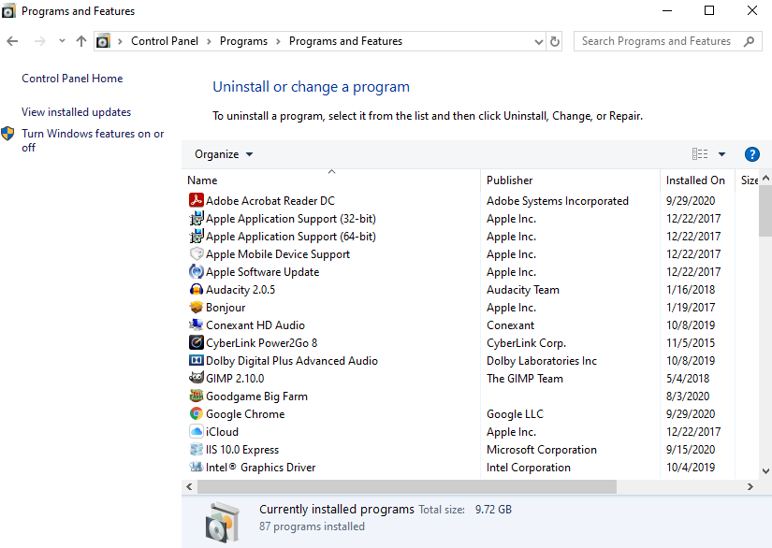

-You need to choose the IT Register Application.

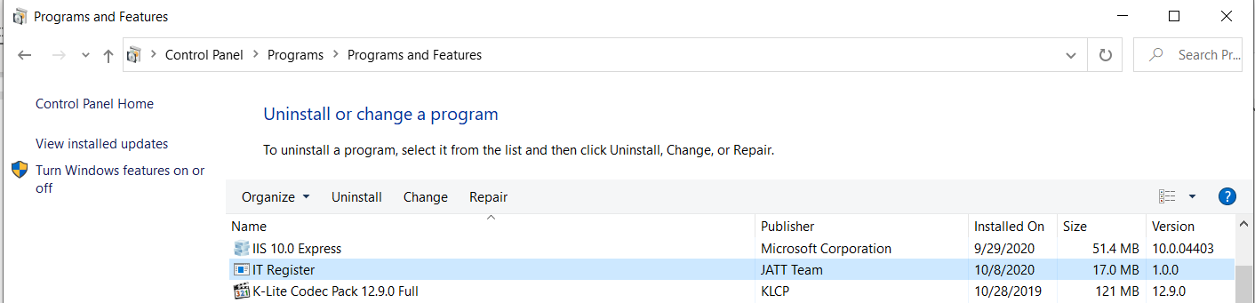

-There will be three options namely Uninstall, Change and Repair

-Choose the Uninstall option.

-Wait for some time while the application is being uninstalled.

-Then there will be an option to restart the computer.

-You can click on Restart option or Restart Later option.

-After restarting the computer, you will see that the IT Register Application has been removed from your computer.

Moreover, there is an alternative option is available to uninstall the application. From the extracted two files ITRegister-Setup and SqlLocalDB-Setup.

* Click on ITRegister-Setup, it will show preparing to install…
* Don’t cancel it. Wait for a while.
* Windows with a message “Welcome to the ITRegSetup Setup Wizard”. Here two options will be given, Repair ITRegSetup and Remove ITRegSetup.
* Click on the Remove ITRegSetup option and then press Finish button.
* So, in this way the program will be successfully removed from your computer.